**THE MUSIC**

**OF**

**MARC-ANDRÉ HAMELIN**

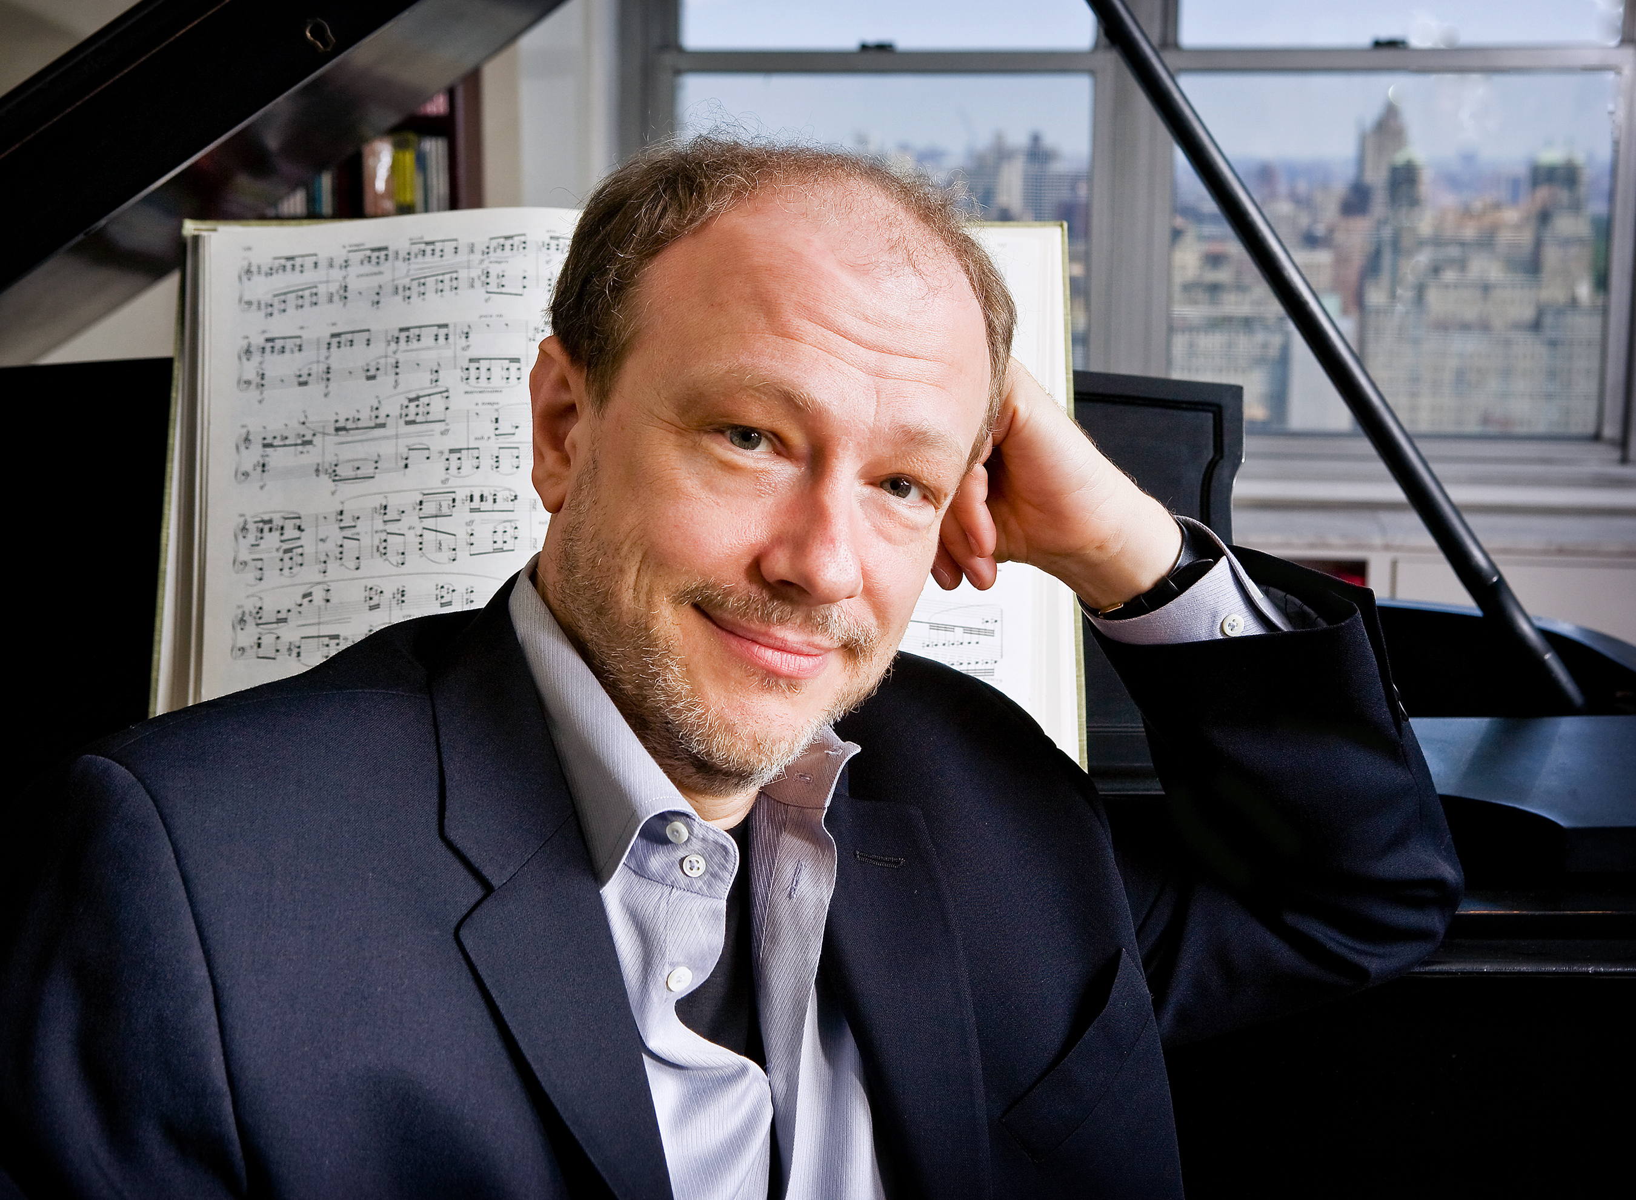

Photo: Fran Kaufman

**CONTENTS**

***GENERAL INFORMATION 02***

***CATALOGUE OF MUSIC 03***

***DISCOGRAPHY 05***

GENERAL INFORMATION

**Marc-André Hamelin** was born in Montréal.  He studied at the Vincent d’Indy School of Music and Temple University in Philadelphia. His principal teachers were Yvonne Hubert, Harvey Wedeen and Russell Sherman. He was the winner of the 1985 Carnegie Hall Competition. He now lives in Boston.

**Marc-André Hamelin** is ranked among the élite of world pianists for his unrivalled blend of musicianship and virtuosity in the great works of the established repertoire, as well as for his intrepid exploration of the neglected music of the 19th and 20th centuries.

Now long established in North America, Europe and the Far East, **Marc-André Hamelin** has given recitals in many cities around the world, including Amsterdam, Belfast, Berlin, Frankfurt, Istanbul, London, Luxembourg, Mexico City, Milan, Montréal, Munich, New York, Paris, Philadelphia, Tokyo, Toronto, Vienna, Washington and Warsaw.  He also has many international festival appearances to his credit.

He has performed concertos with the orchestras of Basel, Birmingham, Chicago, Houston, Indianapolis, Lahti, Minneapolis, Montpellier, Montréal, Netherlands Radio, Philadelphia, BBC (Philharmonic and Scottish Symphony), Polish National Radio, Royal Concertgebouw, Toronto, Ulster, Vancouver, Winnipeg and has toured with the Australian Chamber Orchestra.  Conductors he has played under include Matthias Bamert, Dennis Russell Davies, Andrew Davis, Charles Dutoit, Mark Elder, Christoph Eschenbach, Günther Herbig, Fabio Luisi, Jukka-Pekka Saraste, Leif Segerstam, Vassili Sinaisky, Dmitry Sitkovetsky, Leonard Slatkin, Stanislaw Skrowaczewski, Osmo Vänskä, Hans Vonk, Hugh Wolff and David Zinman.

His exclusive recording contract with the widely regarded UK label Hyperion has resulted in a discography that now exceeds 50 CDs, from Haydn and Mozart through Schumann, Alkan and Liszt, Reger, Debussy, Busoni and Godowsky, Skryabin, Medtner and Symanowski, Roslavets and Ornstein to Shostakovich, Bernstein and Bolcom. He has also recorded an album of his own works. These discs have all been exceptionally well received internationally; the many accolades that they have attracted to date include no less than 9 Grammy awards. In 2014 alone, he was honoured with the ECHO Klassik Instrumentalist of Year (Piano), Disc of the Year by *Diapason* magazine and *Classica* magazine for his 3-CD set of the late piano music of Busoni.

He begins the 2016/17 season with summer festival appearances at the Schubertiade, Verbier, Lofoten and Salzburg, as well as recitals at Tanglewood, Domaine Forget, Aspen, and La Jolla where the La Jolla Music Society commissioned Hamelin to write a sonata for cello and piano for himself and cellist Hai-Ye Ni.

His orchestral engagements this season include weeks with the Montréal and Minnesota orchestras, the Indianapolis Symphony, the Bayerische Staatsorchester with Kirill Petrenko, the NDR Hanover and the symphony orchestras in Gothenburg, Oregon, Bologna, Montpellier and the Warsaw Philharmonic.  Recitals include the Vienna Konzerthaus, Berlin Philharmonic, Gilmore Festival, 92nd St. Y in New York and in other cities including Cleveland, Chicago and Toronto.  Of particular pleasure to him is the opportunity to make his début in China this season with two recitals in the legendary Shanghai Concert Hall in November.

A special project for the season will be duo recitals with Leif Ove Andsnes in Europe at London’s Wigmore Hall as well as in Rotterdam, Dublin, and Italy. His forthcoming appearances in North America include Seattle Symphony, San Francisco Performances, Washington Performing Arts, Wallis Annenberg Center for the Performing Arts in Beverly Hills, Chicago Symphony Presents and Carnegie Hall.

With the Pacifica Quartet, he will tour the world première of his own piano quintet, commissioned by the Segerstrom Center in Orange County, CA and he will conclude the season as a juror at the Cliburn Piano Competition, for which he has been commissioned to write the compulsory solo work for the contestants.

With performances of the concerti of Busoni and Marx, the Chopin/Godowsky and Alkan studies, the sonatas of Medtner and Skryabin, Reger’s Bach Variations, Szymanowski’s Second Sonata and Schmitt’s Piano Quintet, **Marc-André Hamelin** could almost be regarded as having taken Kaikhosru Shapurji Sorabji as one of his principal repertoire guides; to all of these works, largely neglected in and immediately after their own time, Sorabji drew enthusiastic attention in his critical writings.

Like Skryabin and Godowsky before him, **Marc-André Hamelin** has concentrated principally on his own instrument in his compositions and transcriptions, many of which, as may be expected, reflect his own remarkable pianism. His works are published by Edition Peters, Theodore Presser and Schott Musik as well as The Sorabji Archive.

In 2002, Amadeus Press published Robert Rimm’s book *The Composer-Pianists: Hamelin and The Eight*, the result of its author’s long-standing collaboration with **Marc-André Hamelin** which also brought about the Hyperion recording *Marc-André Hamelin Plays the Composer-Pianists*.

In 2005, **Marc-André Hamelin** was honoured to be made Officer of the Order of Canada and a Chevalier de l’Ordre National du Québec. He is the recipient of a lifetime achievement award from the German Record Critics’ Association and a member of the Royal Society of Canada.

For further information and updates on **Marc-André Hamelin**’s recent and forthcoming concerts and compositions, please visit <http://www.colbertartists.com/marc-andre-hamelin>.

Additional information is to be found on various pages at <http://marcandrehamelin.com>.

**CATALOGUE OF MUSIC**

All items unless otherwise indicated are available from:-

the sorabji archive

**WARLOW FARM HOUSE EATON BISHOP HEREFORD HR2 9QF ENGLAND**

|  |  |  |  |  |  |  |  |  |
| --- | --- | --- | --- | --- | --- | --- | --- | --- |
|  | **From UK**  **Ex UK** | **01225 852323**  **+44 1225 852323** |  |  | **From UK** Ex UK | **01225 852523**  **+44 1225 852523** | **E-mail** Website | **sorabji.archive@gmail.com**  **www.sorabji-archive.co.uk** |

How to order from The Sorabji Archive

Orders may therefore be placed in writing via

1. email (the preferred method)
2. fax
3. ordinary mail.

Please note that we do not supply items directly from the website.

Payment

Payments are accepted in £ sterling (GBP) only in favour of The Sorabji Archive by any of the following means:

|  |  |  |  |  |  |
| --- | --- | --- | --- | --- | --- |
| PAYMENT TYPE | PAYMENT CONDITIONS | PAYMENT METHOD | | | |
| *Direct credit to our bank* | *Made from a UK £ sterling bank account only* | Bank  *Coutts & Co.* | A/c  *A Hinton* | Sort Code  *18-00-02* | A/c No.  *09231331* |
| *PayPal* |  | *Please input our e-mail address* [*sorabji.archive@gmail.com*](mailto:sorabji.archive@gmail.com) *when prompted to do so* | | | |
| *Personal/company cheque* | *Drawn on a UK £ sterling bank account only* | *By mail to the above address* | | | |
| *Bank draft* | *Negotiable on a UK £ sterling bank account only* | *By mail to the above address* | | | |
| *UK£ Travellers’ cheques* |  | *By mail to the above address* | | | |
| *Crossed UK Postal Order* |  | *By mail to the above address* | | | |

Terms: in advance All items remain the property of The Sorabji Archive until paid for in full

Supply format and item description

1. All items, including computer-set editions and autograph manuscripts, are issued on paper as duplex (double-sided) photocopies, enlarged where practicable to aid legibility and ring-bound in hard card covers unless otherwise specified or requested; alternatively, all items may be supplied electronically in .pdf format.

Editions

* Editions are either typeset or in the editor’s hand, described as “Ed.” and duly credited; “***Published***” items and forthcoming publications in ***boldface italics*** are no longer supplied by us, so please contact their publishers or retail agents.

Copy quality

* Master copies of all items supplied in paper form have been prepared by The Sorabji Archive from original autograph manuscripts and typeset editions.
* All paper copies supplied are prepared in-house to order. Copy quality is the highest achievable from the originals using the archive’s analogue monochrome photocopier which, whilst it served us well over the years, has since been replaced with an equivalent digital copier upon which all paper copies are made for distribution.

A guide to the catalogue

* The **Date** column gives the year of completion of each work or the years in which it was composed or revised.
* The **No.** column shows the composer’s work numberings.
* The **Dedicatee** column shows the names of dedicatees where applicable and known.
* **Durations** are given in minutes; those of works yet to be performed are allotted estimates in the form “c.[xxx’]”.
* The **Pages** column shows the number of pages in each item and indicates how their prices are calculated.
* The **Format** column gives paper size / orientation: P = Portrait and L = Landscape.
* The **Edition** column gives descriptions of the publication format of each item. All items without such a description are copies of the composer’s autograph manuscripts. The designation “Ms.” likewise refers to autograph manuscripts but appears only in instances where other edition formats of the same work are also available.
* The **Price (paper)** column shows the amount in £ sterling (GBP) payable for each item including packing and ordinary mailing **within UK only**; prices remain valid until further notice. Surcharges for guaranteed, express or other special mailing / shipping services and for **all orders to be shipped outside UK** are quoted on request. In the interests of our valued customers we no longer ship items by sea mail due to adverse past experience; it may in some cases appear somewhat more economical, but we have also found it to be very unreliable. **Most of our prices have remained unchanged since the Archive’s foundation, despite increases in costs of materials and shipping**.
* The **Price (.pdf)** column shows the amount in £ sterling (GBP) payable for each item as an uploaded .pdf file; we have offered this service since June 2012 as an alternative to paper copies for those who wish to have items in this format.

Files in .pdf format

We have been offering material in this format, either as attachments to emails or via file transfer software such as WeTransfer since June 2012. The advantage of these, for those who prefer them, is that they are much cheaper than paper copies and can be sent very promptly, whereas paper copies are subject to shipping costs and can take days to arrive.

It has come to our attention that some enquirers have difficulty in receiving very large files this way; this appears to be down to the recipient’s operating system and the default .pdf software that comes with it. Whereas Microsoft™ Windows® users have Adobe Reader as the default .pdf programme and this seems not to give rise to any file receiving problems, users of other operating systems that do not come with Adobe Reader as default software may encounter problems. The easy solution is to visit <http://get.adobe.com/uk/reader/> and download Adobe Reader, which is free software.

**Reproduction by any means of all or any part or parts of all musical works printed or otherwise by Marc-André Hamelin and its sale hire or distribution except by prior written consent of Marc-André Hamelin or his authorised agents or suppliers shall constitute infringement of copyright and is therefore unlawful.**

**This catalogue is regularly updated to incorporate new and newly completed editions, recently discovered works (if any) and other new information. Please refer to copyright date when comparing earlier issues.MUSICAL WORKS BY MARC-ANDRÉ HAMELIN**

**Pages Date Dedicatee/s Duration Format Edition Price (paper) Price (.pdf)**

**CHAMBER ENSEMBLE**

Fanfares for 3 Trumpets 2003 3’  ***Published (Presser, USA)***

Piano quintet 2016 30’ ***To be published (Edition Peters)***

Four Perspectives for cello and piano 2016? 11’ ***To be published (Edition Peters)***

**PIANO**

Two Short Studies 1979-80 (i) Ronn Yedidia 1’ ***Published (Edition Peters: On The Short Side vol.)***

(ii) Clément Rondeau 1½’

Preambulum to an Imaginary Piano Symphony (Homage to 4 1989 Marc-André Roberge 1½’ A3P WITHDRAWN

Kaikhosru Shapurji Sorabji, 1892-1988)

Étude fantastique sur *Le Vol du Bourdon* de Rimsky- Korsakov 1987 3’ ***Published (Edition Peters: On The Short Side vol.)***

12 Études in All The Minor Keys 1984-2009 50’ ***Published (Edition Peters)***

Cadenzas to Piano Concertos K453/491 (Mozart) 8 1994-97 4’ A3P £15 £10

Cadenzas to Beethoven’s Fourth Piano Concerto, op.58 6 2007 Cathy Fuller 4’ ***Published (Edition Peters)***

Tico-Tico No Fubá (Abreu, transc. Hamelin) 1995 Ronn Yedidia 3’ ***Published (Schott)***

Prélude (retitled No choice but to run) 1995 Gülsin Onay 1’ ***Published (Edition Peters: On The Short Side vol.)***

Cadenza to Hungarian Rhapsody No. 2 (Liszt) 1995 3’ ***Published (Edition Peters: On The Short Side vol.)***

Con Intimissimo Sentimento (7 short pieces) 1986-2000 Jessica Duchen / 22’ ***Published (Edition Peters)***

Tom Eisner

The Ringtone Waltz 2000 1½’ ***Published (Presser USA)***

Glazunov/Hamelin: *Petit Adagio* from *The Seasons* 2001 Jessica Duchen 3’ ***Published (Edition Peters: On The Short Side vol.)***

Petite page d’album 2006 Makoto Tagaya / 2’ ***Published (Edition Peters: On The Short Side vol.)***

Tomoko Miyokawa

Theme and Variations (Cathy’s Variations) 2007 Cathy Fuller 10’ ***Published (Edition Peters)***

Little Nocturne 2007 Eric Bruskin 2’ ***Published (Edition Peters: On The Short Side vol.)***

Suggestion diabellique 2008 1’ ***Published (Edition Peters: On The Short Side vol.)***

Variations on a theme of Paganini 2011 Yehudi Wyner / 10’ ***Published (Edition Peters)***

Susan Davenny Wyner

Meditation on *Laura* (David Raksin: from the film *Laura*) 2011 Jenny Lin 5’ ***Published (Edition Peters: On The Short Side vol.)***

Cadenzas to Haydn Piano Concertos Hob. XVIII 3 & 4 6 2012 5’ A3P ***Published (Edition Peters)***

Chopin/Godowsky compl. Hamelin: Étude No. 44A 2012 3’ ***Published (Edition Peters: On The Short Side vol.)***

Chopin/Hamelin: The Minute Waltz, in seconds 2012 2’ ***Published (Edition Peters: On The Short Side vol.)***

Chaconne 2013 Elisabeth Schock 9’ ***Published (Edition Peters)***

Barcarolle 2013 Leif Ove Andsnes 9’ ***Published (Edition Peters)***

Pavane variée 2014 Emanuel Ax 10-11’ ***Published (Edition Peters)***

My feelings about chocolate 2014 Paul and Moni Lenz 2’ ***Published (Edition Peters: On The Short Side vol.)***

**Pages Date Dedicatee/s Duration Format Edition Price (paper) Price (.pdf)**

**SIX PIANOS**

Joplin/Hamelin: *Maple Leaf Rag* 1996 Angela Cheng / 3’ ***Published (Presser, USA)***

Janina Fiałkowska /

Angela Hewitt /

André Laplante /

Jon Kimura Parker

**PLAYER-PIANO**

Circus Galop 22 1991-94 Beatrix / Jürgen Hocker 4½’ A3P £15 £10

Pop Music (a fantasy on *Pop Goes the Weasel*) 10 1998 Georges Nicholson 4’ A3P £15 £10

Solfeggietto a Cinque (after C P E Bach) 20 1999 4’ A3P £15 £10

**DISCOGRAPHY**

For full details of Marc-André Hamelin’s extensive discography, please visit <http://www.marcandrehamelin.com/artist.php?view=record>.

© 09.07.2023